ФИО (полностью) | Казина Елена Павловна  МБОУ Гимназия № 91, г.Железногорск Красноярского края
Название статьи (полностью) | The Symbol of the Soviet People’s Heroism  Символ героизма советского народа
Язык | английский
Класс | 7-8
E-mail | elesha22@yandex.ru
Методическая разработка «Символы победы», посвященная 75летию Победы

Урок разработан в соответствии с требованиями ФГОС ООО.
Цели мероприятия:
воспитание чувства патриотизма у подростков, формирование чувства долга, благодарности перед памятью павших на Великих фронтах Вов; развитие кругозора.
Планируемые результаты:
познавательные УУД: смысловое чтение как осмысление цели чтения , извлечение информации из читаемых текстов;
личностные УУД: жизненное самоопределение личности, нравственно-этическая ориентация, оценивание усваиваемого содержания;
регулятивные УУД: целеполагание как постановка учебной задачи на основе соотнесения того, что уже известно учащимся, и того, что еще не известно, саморегуляция, умение преодолевать сложности;
коммуникативные УУД: умение чётко и лаконично выражать свои мысли в соответствии с задачами и условиями коммуникации, владение монологической речью.
Ожидаемые результаты: вызвать эмоциональный отклик в сердцахшкольников;
желание выразить отношение к войне, к подвигу русского народа в годы войны.

Victory Day unites both young and old people of Russia. Each family can tell the stories of their grandfathers and great-grandfathers who have defended the freedom not only of Russia, but also of Europe. The Russian people paid a high price for this Victory, and to this day they remember and honor the millions who died.
Symbols of Victory
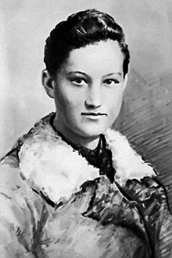
Who is the person in the picture?
What is she famous for?
https://russiapedia.rt.com/files/prominent-russians/history-and-mythology/zoya-kosmodemyanskaya/zoya-kosmodemyanskaya_4.jpg

The Symbol of the Soviet People’s Heroism
She was the first woman awarded with the title of Hero of the Soviet Union during World War II. Her image is depicted in fiction, essays, movies and art.
Zoya Kosmodemyanskaya was born in a village near the city of Tambov. Zoya did well in school, was especially fond of history and literature. Her teachers noted her essays for deep understanding of the subject and for imagery. She read far beyond the curriculum. The list of authors she read included Leo Tolstoy, Pushkin, Mikhail Lermontov, Karamzin, Vasily Zhukovsky, Byron, Molière, Miguel Cervantes, Charles Dickens, Wolfgang Goethe, and William Shakespeare.
In October 1941, still a high school student in Moscow, she volunteered for a partisan unit. To her mother, who tried to dissuade her, she answered "What can I do when the enemy is so close? If they came here I would not be able to continue living."
Kosmodemyanskaya and other partisans crossed the front line and entered territory occupied by the Germans. They mined roads and cut communication lines. On November 27, 1941 Zoya received an assignment to burn the village of Petrischevo, where a German cavalry regiment was stationed. Zoya managed to set fire to horse stables and a couple of houses. However, the Germans caught Zoya. At the interrogation, Zoya said her name was Tanya and refused to say anything definite. She didn’t disclose any information about her friends. The Germans hung her. Her final words were "Comrades! Why are you so gloomy? I am not afraid to die! I am happy to die for my people!"
Many streets, farms and Pioneer organizations in our country are named after Zoya Kosmodemyanskaya.
Our school is the oldest in our town of Zheleznogorsk. In 1968 its Pioneer organizations was named after Zoya Kosmodemyanskaya. There is a monument to Zoya in front of the school.
https://photos.wikimapia.org/p/00/05/32/69/10_big.jpg

VOCABULARY
Complete the definitions. Circle the letter of the correct answer.
- A group of houses, stores, and other buildings which are smaller than a town.
A a park B a city C a village
- A a piece of writing that , generally,gives the author's own argument
A a letter B an essay C a novel
- A person who hates or opposes another person and tries to harm them
A a brother B an enemy C a comrade
- A horse stable
A horse riding B horse meal C a farm building for housing horses
- To interrogate
A to hang B to occupy C to ask someone a lot of questions for a long time in order to get information
COMPREHENSION
Circle T if it is true? F if the sentence is false, or DS(doesn’t say)
- Zoya Kosmodemyanskaya was the first woman awarded with the title of Hero of the Soviet Union during World War I.
- Zoya had a brother called Sasha.
- Zoya was a schoolgirl when the war began.
- The Germans didn’t know Zoya’s real name.
- One of the streets in our town of Zheleznogorsk is named after Zoya Kosmodemyanskaya.

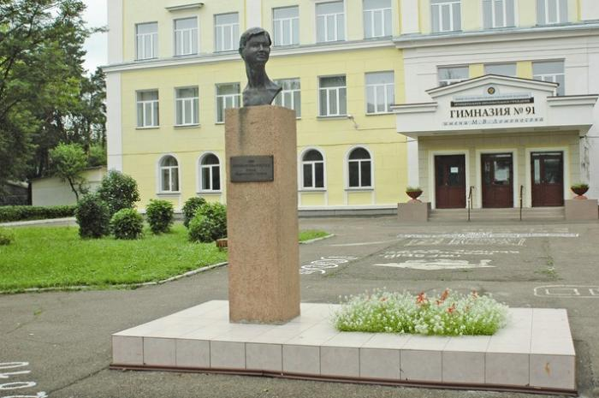
DISCUSS
- Do you know when the Great Patriotic War started?
- What country attacked our Motherland?
- Do you know how many people our country lost?
- Do you know that many children became partisans?
- When did the Great Patriotic War end?

ACTIVITY
- Do you know any heroes of the war?
- Did any of your relatives take part in the war
Write and tell us about it

The key
1A 2 B 3 B 4C 5C 6F 7DC 8T 9T 10F

